**UNLOCKING INSIGHTS INTO THE GLOBAL AIR TRANSPORTATION NETWORK WITH TABLEAU**

**Project work submitted by**

**Roll No: C21UG105STA024 Name: K.Shanmugasundharam**

**C21UG105STA026 C.Srinath**

**C21UG105STA027 S.Sriram**

**C21UG105STA001 S.Adithya**

**Under the Guidance of**

**Dr. M. GOVINDHAN, M.Sc., Ph.D**

**Guest Lecturer**

**DEPARTMENT OF STATISTICS**

**GOVERNMENT ARTS COLLEGE**

**DHARMAPURI – 636 705**

**(Affiliated to Periyar University, Salem)**

**OCTOBER -2023**

**1. INTRODUCTION**

**1.1OVERVIEW**

The global air transportation network dataset is a comprehensive collection of information on airports, airlines and their routes

With clear insights these dashboard afford a comprehensive view of performance including sales and daily operations and informs flight schedules and airline.

**1.2 PURPOSE**

It contains information such as names, cities, countries, codes (IATA and ICAO) longitudes, latitudes and altitudes of airports across the world with detailed time zone and daylight saving time data.

**1.3 ADVANTAGES & DISADVANTAGES**

**Advantages**

**1**. Data Visualization: Tableau allows you to create interactive and visually appealing charts, graphs, and maps, making it easier to understand complex air transportation data.

2. Quick Insights: It enables you to analyse large datasets quickly, identifying trends, patterns, and anomalies in the global air transportation network.

**Disadvantages**

**1**. Learning Curve: Tableau has a learning curve, and mastering its features and functions may require time and training.

2. Cost: Tableau licenses and subscriptions can be expensive, which may be a barrier for smaller organizations or individuals.

**1.4 APPLICATION**

**1.** *Route Optimization:* Airlines can use Tableau to analyse historical flight data and passenger demand to optimize their flight routes. This can lead to more efficient scheduling, reduced fuel consumption, and lower operating costs.

2. *Demand Forecasting:* Tableau can help airlines and airports predict future passenger demand based on historical data and external factors such as economic indicators or seasonal trends. This information can guide capacity planning and resource allocation.

3. *Customer Segmentation:* Airlines can segment their customer base using Tableau to better tailor marketing strategies, loyalty programs, and in-flight services to specific passenger groups, enhancing customer satisfaction and profitability.

**2. PROBLEMS DEFINITION & DESIGN THINKING**

**Fig:1 Empathy Map**

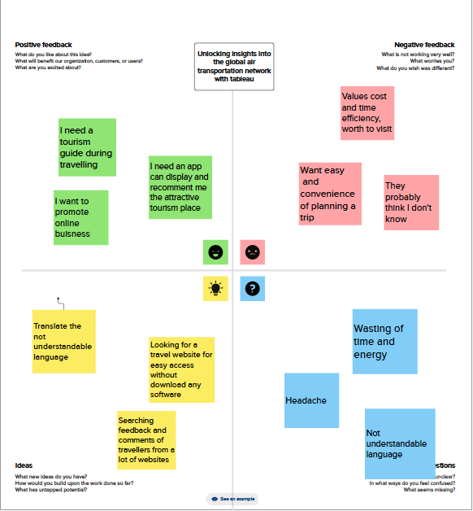

**Discussion**

When applied to unlocking insights into the global air transportation network with Tableau, it can help you gain a deeper understanding of the needs and perspectives of the people involved in analyzing and using such data.

**Fig:2 Ideation & Brain storming Map**

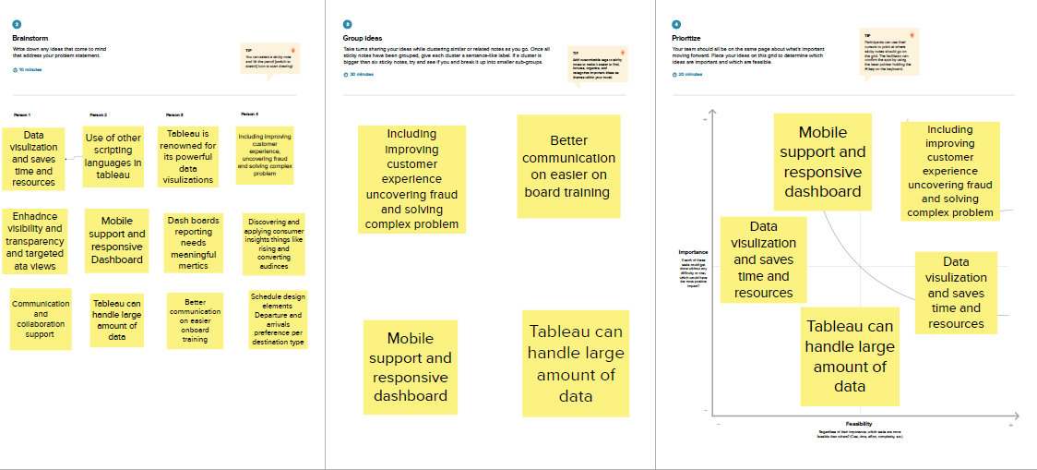

**DISCUSSION**

Creating a brainstorm map for unlocking insights into the global air transportation network using Tableau involves identifying key data sources, visualization techniques, and analysis goals.

**3.STATISTICAL ANALAYSIS**

**Fig:3 Data Source Connection**

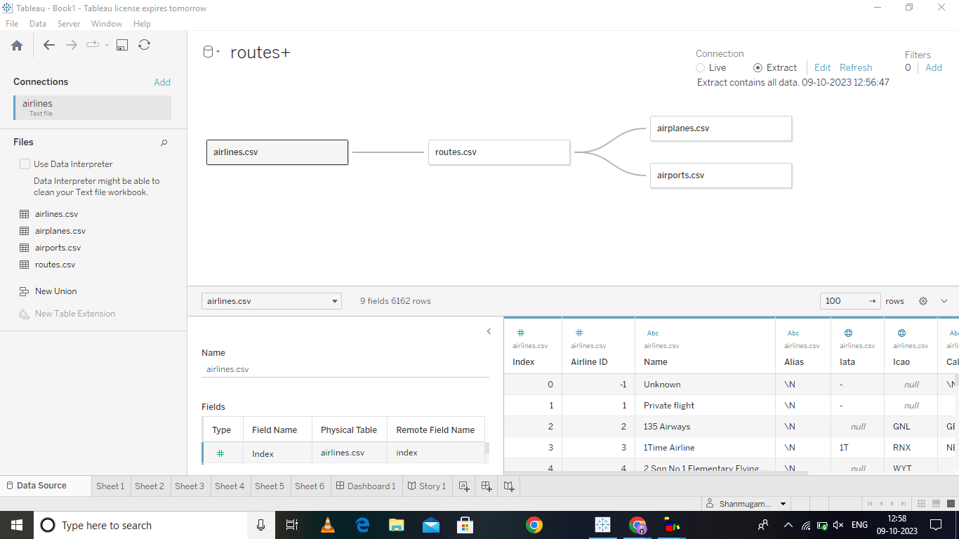

Discussion

Unlocking insights into the global air transportation network with Tableau would typically require access to data sources that provide information about flight routes, airline performance, passenger demographics, and more.

**Fig:4 Airports in the country**

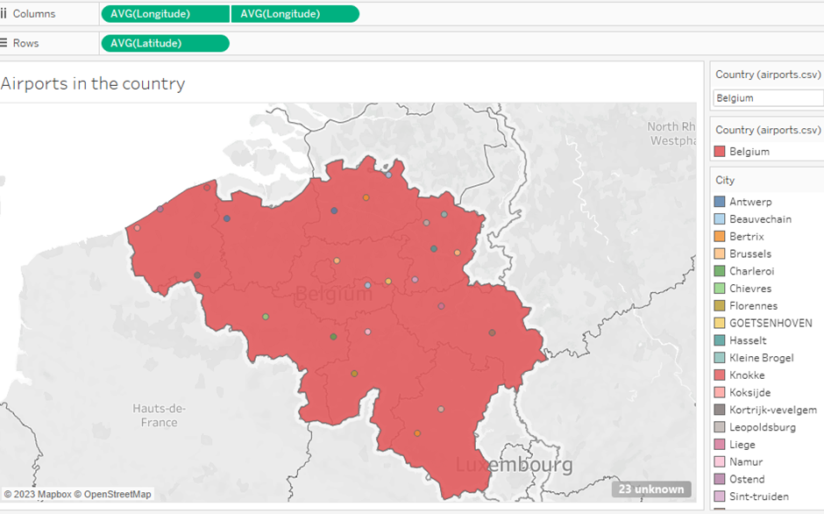

**Discussion**

Analyzing airports in Belgium to unlock insights into the global air transportation network using Tableau can be a valuable project. Here's a general outline of how you might approach this: *Data Visualization in Tableau*:

- *Map Visualization*: Create a map in Tableau to display all airports in Belgium.

- *Passenger Traffic*: Visualize passenger traffic at these airports, possibly using bar charts or a heatmap.

**Fig:5 Number of flights from country**

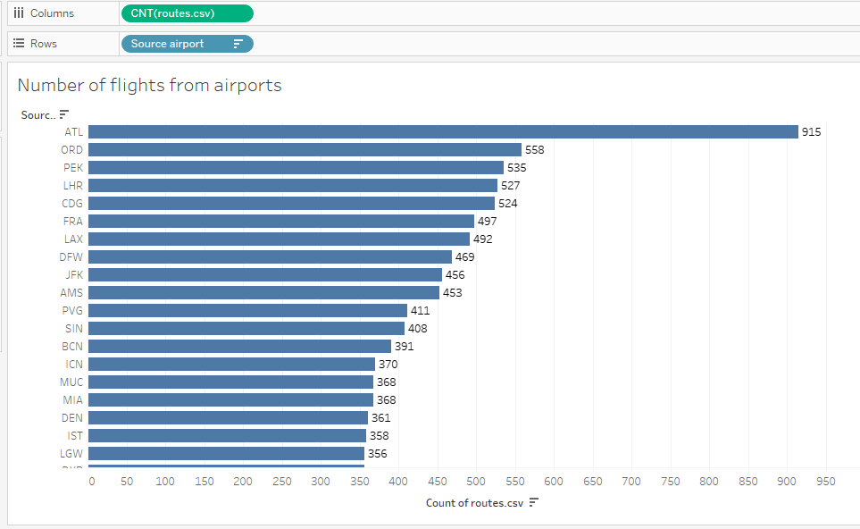

**Discussion**

Data Preparation: Clean and format the data for analysis. Ensure that it's structured properly, with fields like airport codes, locations, flight routes, and passenger statistics

*Airlines*: Some airlines provide data APIs or datasets related to their flight schedules, on-time performance, and passenger information. Contacting airlines directly or checking their developer resources can be helpful..

It involves (CNT) routes in columns and Source airport in the rows.

**Fig:6 Higher airports in the country**

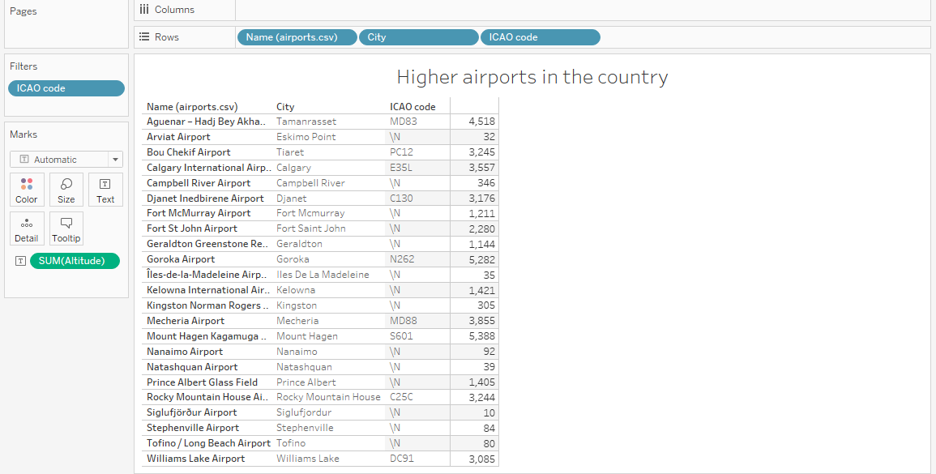

**Discussion**

Tableau is a powerful data visualization tool that can help you unlock insights into the global air transportation network.

. Data Collection: Obtain datasets related to airports, flights, and other relevant information. You can find such data from sources like aviation authorities, airlines, or open data portals.

Higher airports in the country involves name of airports, city , (ICAO) code in columns and (ICAO)code in filters.

**Fig:7 Airports at higher altitude with in country**

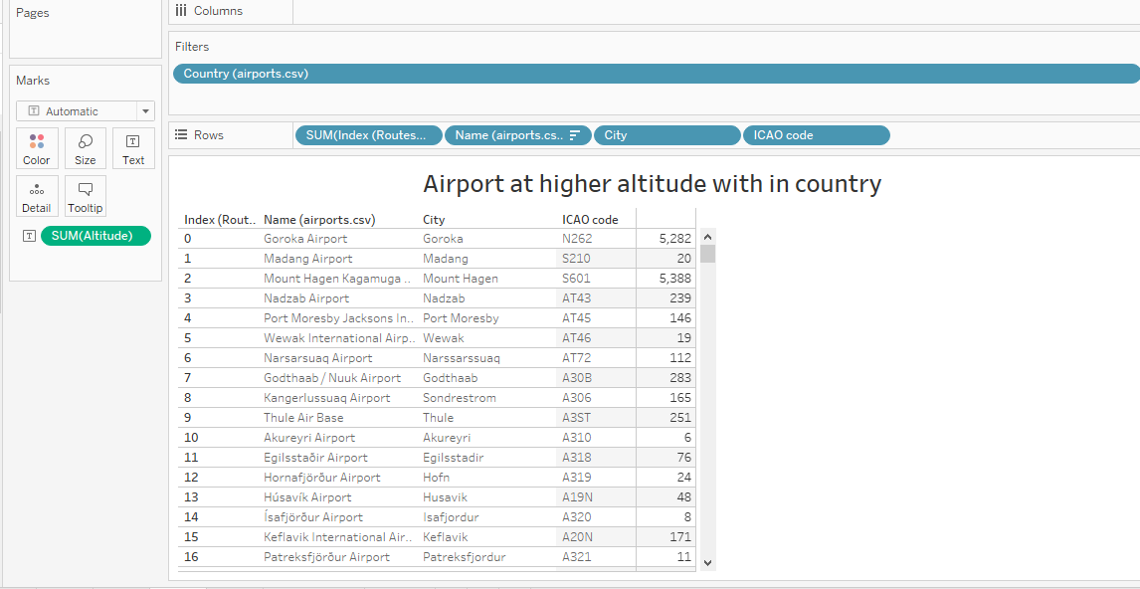

**Discusion**

Airports at higher altitudes within a country can be found in various mountainous regions or elevated plateaus.

**Fig:7 Airlines with in a country**

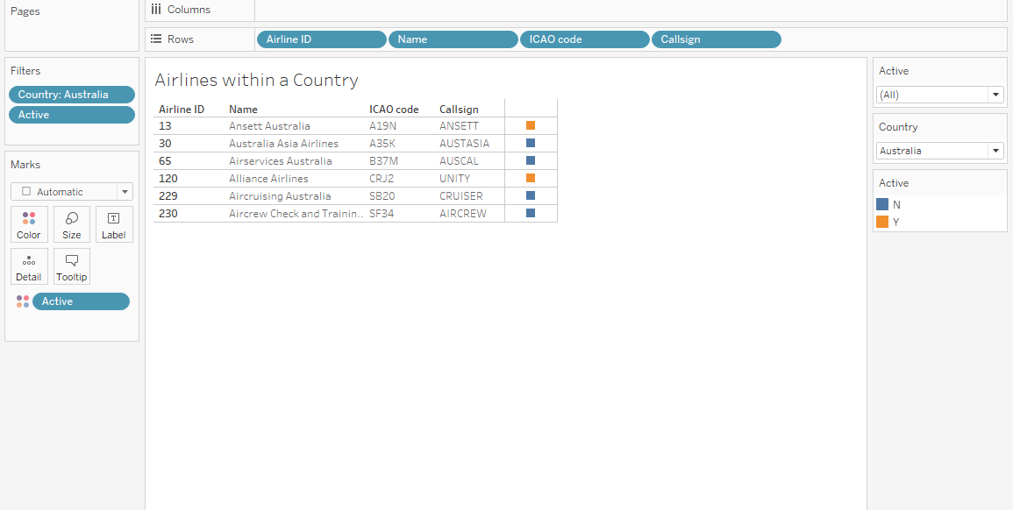

**Discussion**

Unlocking insights into the global air transportation network with Tableau involves analyzing and visualizing data related to airlines and their respectives.

It involves Airline ID,name ,ICAOcode and callsign in rows.

**Fig:8 Dashboard**

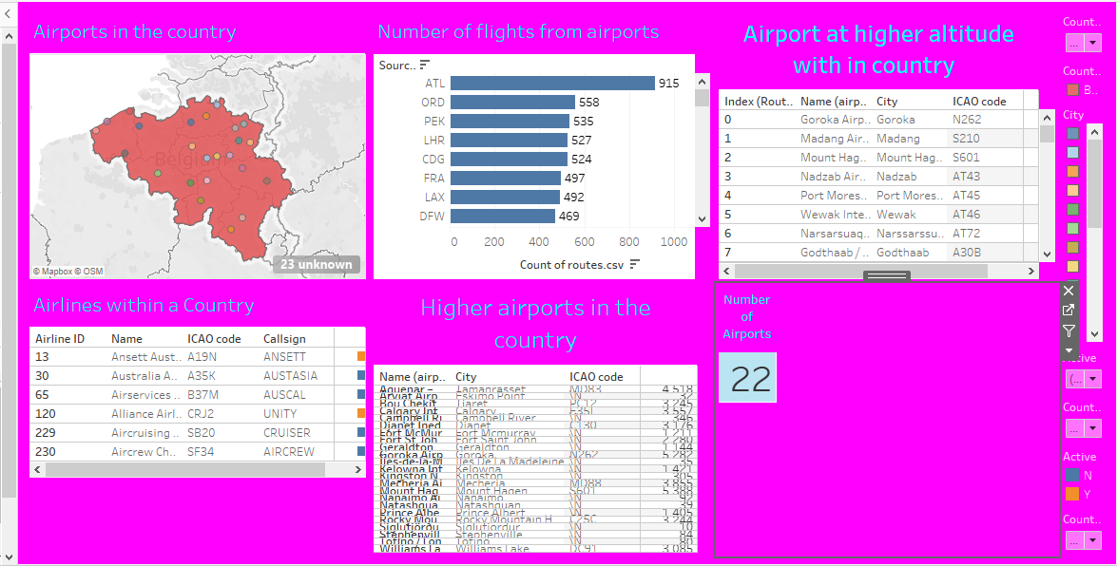

**Discussion**

1. *Data Collection and Preparation:*

- Gather data from reliable sources like aviation authorities, airlines, or open datasets.

- Clean and format the data to ensure it's ready for analysis**.**

2. *Data Import in Tableau:*

- Open Tableau and connect it to your prepared dataset.

3. *Define Objectives:*

- Determine the specific insights you want to gain from the air transportation data. For example, you might want to analyze flight routes, delays, passenger trends, or airline performance.

**4. SUMMARY & CONCLUSION**

1. Route Optimization: Tableau can help identify underperforming routes and suggest more profitable alternatives, leading to cost savings for airlines.

2. Demand Analysis: By analysing passenger data and trends, Tableau can assist in understanding passenger preferences and optimizing flight schedules accordingly.

3. Airport Efficiency: Tableau can help airports enhance their operations by visualizing passenger flow, baggage handling, and security processes, leading to improved customer experiences.

**5. FUTURE SCOPE**

1. *Data Integration*: Tableau can integrate diverse data sources, including real-time data from airlines, airports, weather services, and more. This integration will become even more advanced, providing a comprehensive view of the air transportation ecosystem.

2. *Visual Analytics*: Tableau's visual analytics capabilities will continue to evolve, enabling users to create more complex and interactive visualizations. This will help in better understanding trends, traffic flows, and anomalies in the global air transportation network.

3. *Predictive Analytics*: Future applications of Tableau may incorporate predictive analytics to forecast flight delays, passenger demand, and route optimization. Machine learning algorithms can be integrated to make more accurate predictions.